## User Interface Design

### Guest Interface Design

#### Home

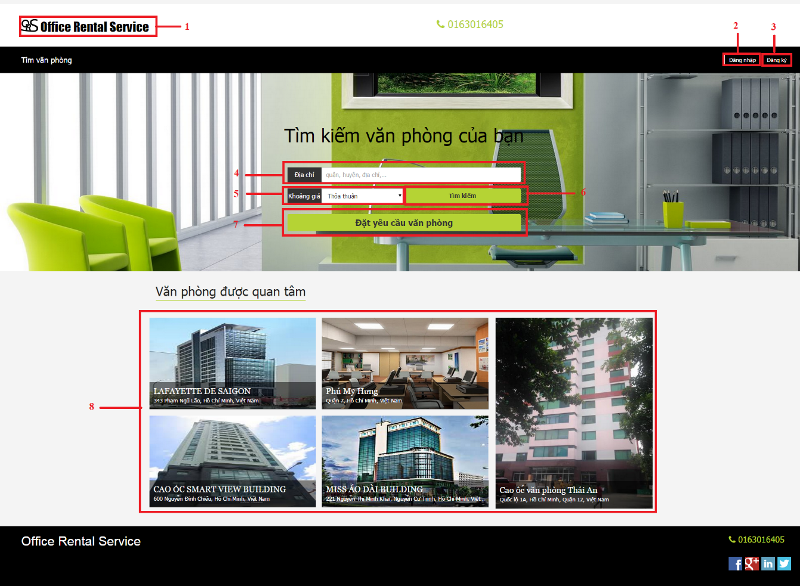

Figure 106: Home

**Fields**

|  |  |  |  |  |  |  |  |
| --- | --- | --- | --- | --- | --- | --- | --- |
| **No** | **Field Name** | **Description** | **Read only** | **Mandatory** | **Control Type** | **Data Type** | **Length** |
| 4 | Address | Address of office for searching | No | Yes | Textbox | String | N/A |
| 5 | Price | Price of office for searching | No | Yes | Dropdown list | String | N/A |

**Buttons/Hyperlinks**

|  |  |  |  |  |
| --- | --- | --- | --- | --- |
| **No** | **Function** | **Description** | **Validation** | **Outcome** |
| 1 | N/A | Link to homepage | N/A | Transfer to home page |
| 2 | Login | Click to login into the system | Yes | Transfer to home page |
| 3 | Register | Click to register a new account | N/A | Transfer to register page |
| 6 | Search | Click to find office base on address and price | Yes | Transfer to office list page |
| 7 | Request Office | Click to create request office | N/A | Transfer to request office page |
| 8 | Office detail | Click to see office detail | N/A | Transfer to office detail page |

#### Rental page

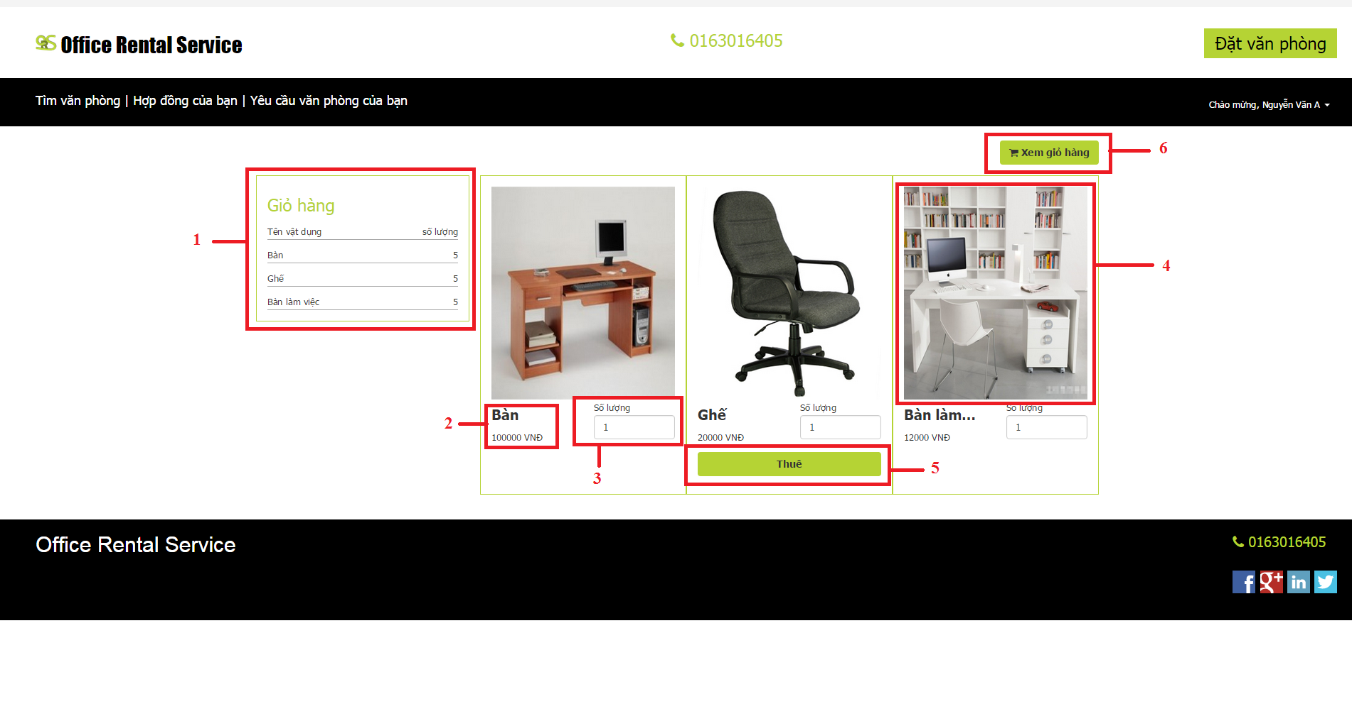

Figure 106: Rental page

**Fields**

|  |  |  |  |  |  |  |  |
| --- | --- | --- | --- | --- | --- | --- | --- |
| **No** | **Field Name** | **Description** | **Read only** | **Mandatory** | **Control Type** | **Data Type** | **Length** |
| 1 | Cart | Show cart of customer | Yes | No | Textbox | String | N/A |
| 2 | Price | Price of rental item | Yes | No | Textview | String | N/A |
| 3 | Quantity | Number items customer buy | No | Yes | Textbox | Int | N/A |
| 4 | Image | Image of the rental item | Yes | Yes | Image | String | N/A |

**Buttons/Hyperlinks**

|  |  |  |  |  |
| --- | --- | --- | --- | --- |
| **No** | **Function** | **Description** | **Validation** | **Outcome** |
| 5 | AddToCart | Add item with quantity to customer’s cart | N/A | Show successful message |
| 6 | viewCart | Open rental cart page | N/A | Transfer to rental cart page |

#### Rental cart page

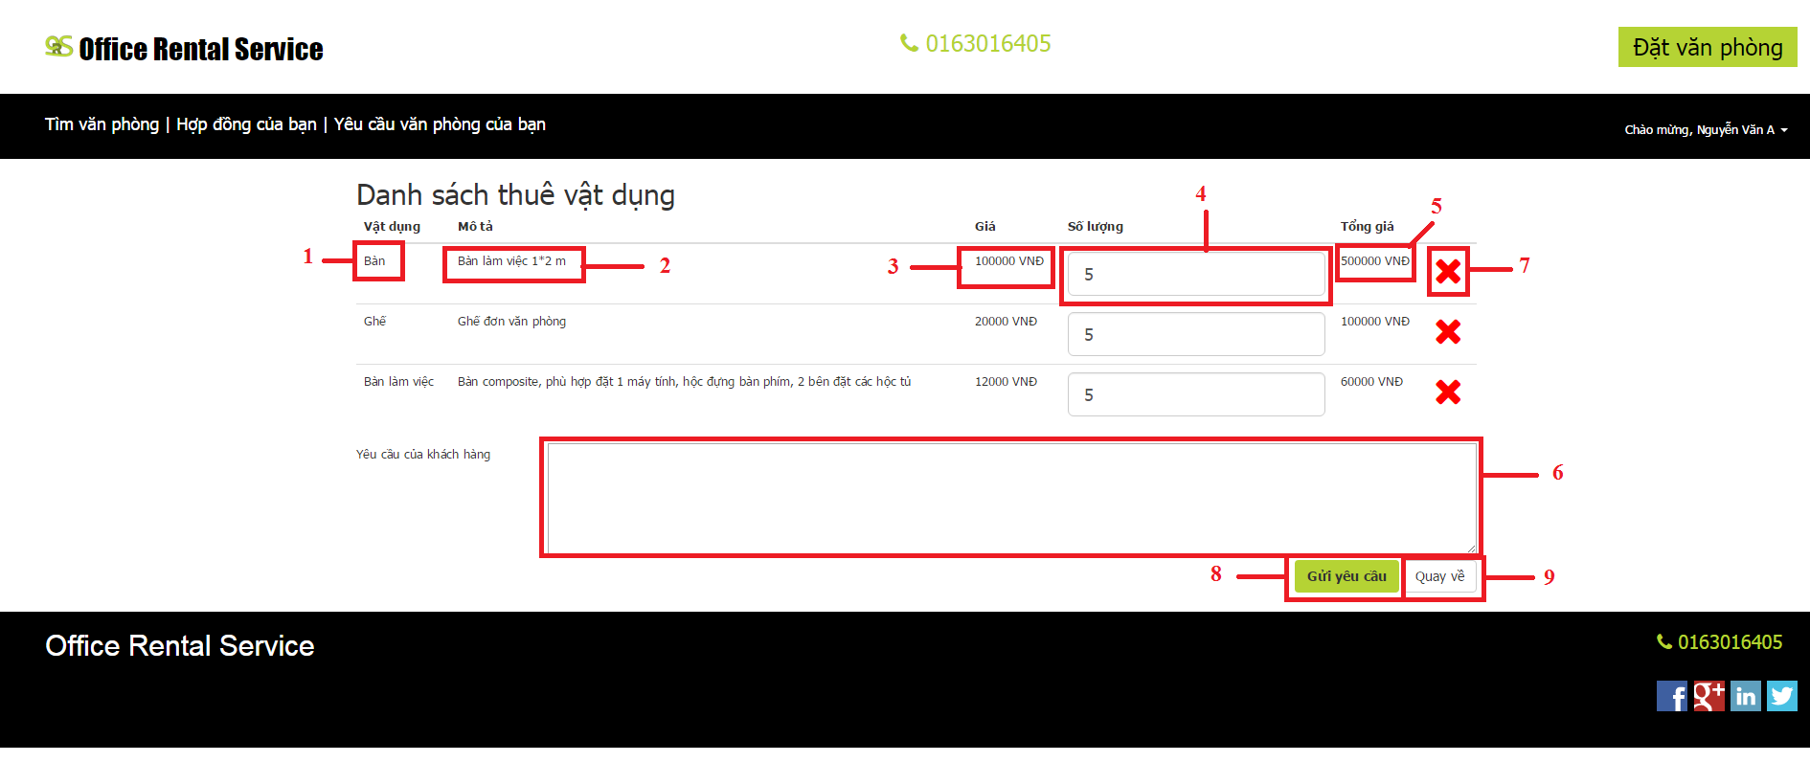

Figure 106: Rental cart page

**Fields**

|  |  |  |  |  |  |  |  |
| --- | --- | --- | --- | --- | --- | --- | --- |
| **No** | **Field Name** | **Description** | **Read only** | **Mandatory** | **Control Type** | **Data Type** | **Length** |
| 1 | Name | Name of items | Yes | Yes | Textview | String | N/A |
| 2 | Description | Description of items | Yes | No | Textview | String | N/A |
| 3 | Price | Price of one item | Yes | Yes | Textview | Int | N/A |
| 4 | Quantity | Number items customer buy | No | Yes | Textbox | String | N/A |
| 5 | Total price | Total price of items | Yes | Yes | Textview | Int | N/A |
| 6 | Comment | Comment of customer | No | No | Textbox | String | N/A |

**Buttons/Hyperlinks**

|  |  |  |  |  |
| --- | --- | --- | --- | --- |
| **No** | **Function** | **Description** | **Validation** | **Outcome** |
| 7 | RemoveFromCart | remove item from customer’s cart | N/A | Show successful message |
| 8 | Send Request | Send request | N/A | Transfer to home page |
| 9 | Hyperlinks | Return to rental page | N/A | Transfer to rental page |

#### Rental list page

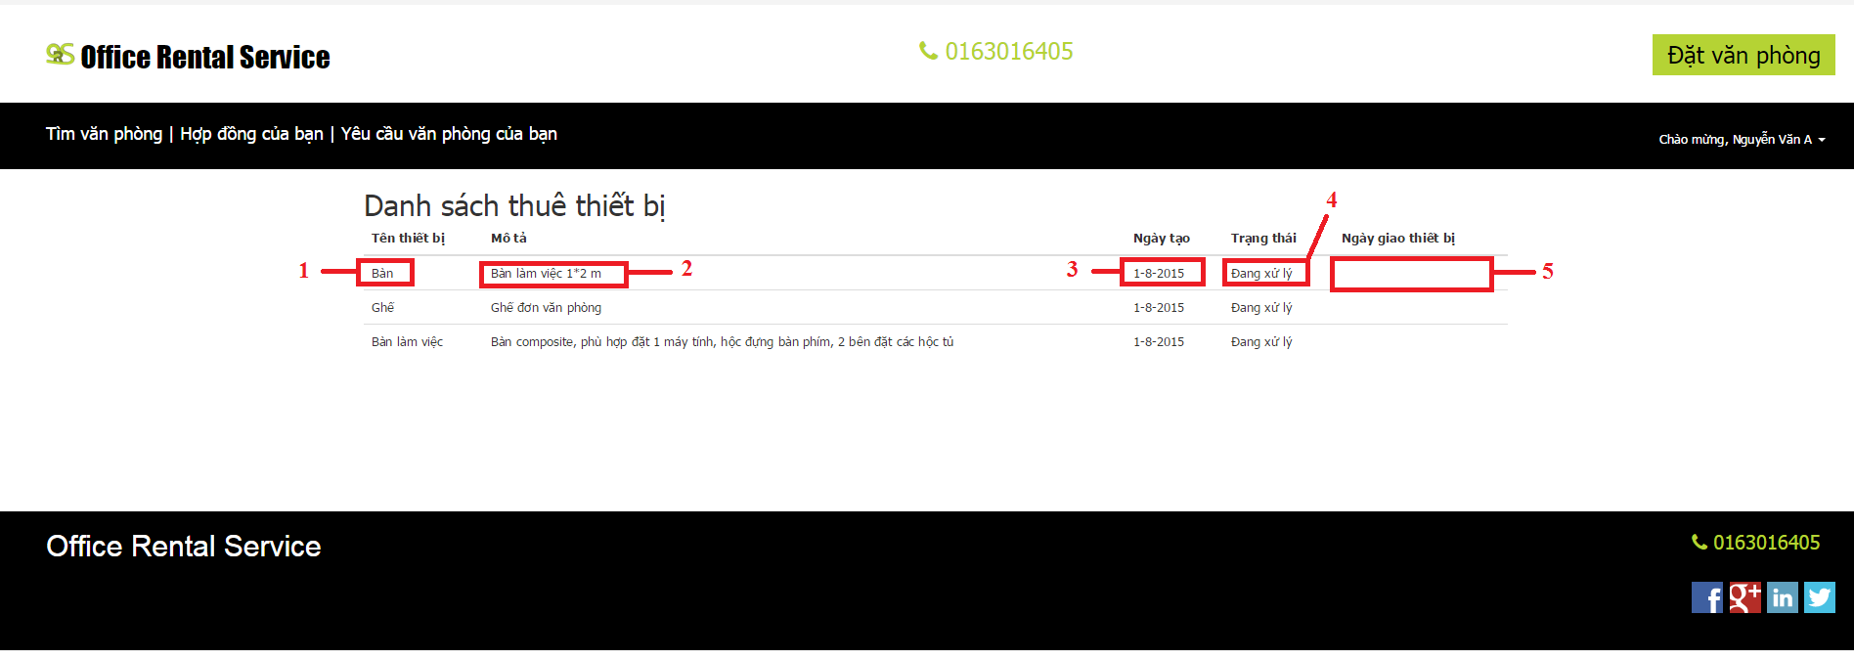

Figure 106: Rental list page

**Fields**

|  |  |  |  |  |  |  |  |
| --- | --- | --- | --- | --- | --- | --- | --- |
| **No** | **Field Name** | **Description** | **Read only** | **Mandatory** | **Control Type** | **Data Type** | **Length** |
| 1 | Name | Name of items | Yes | Yes | Textview | String | N/A |
| 2 | Description | Description of items | Yes | No | Textview | String | N/A |
| 3 | Create date | Date when customer create request | Yes | Yes | Textview | datetime | N/A |
| 4 | Status | Status of request | Yes | Yes | Textview | String | N/A |
| 5 | Assign date | Date customer receive items | Yes | Yes | Textview | datetime | N/A |

**Buttons/Hyperlinks**

|  |  |  |  |  |
| --- | --- | --- | --- | --- |
| **No** | **Function** | **Description** | **Validation** | **Outcome** |
|  |  |  |  |  |

#### Result request office page

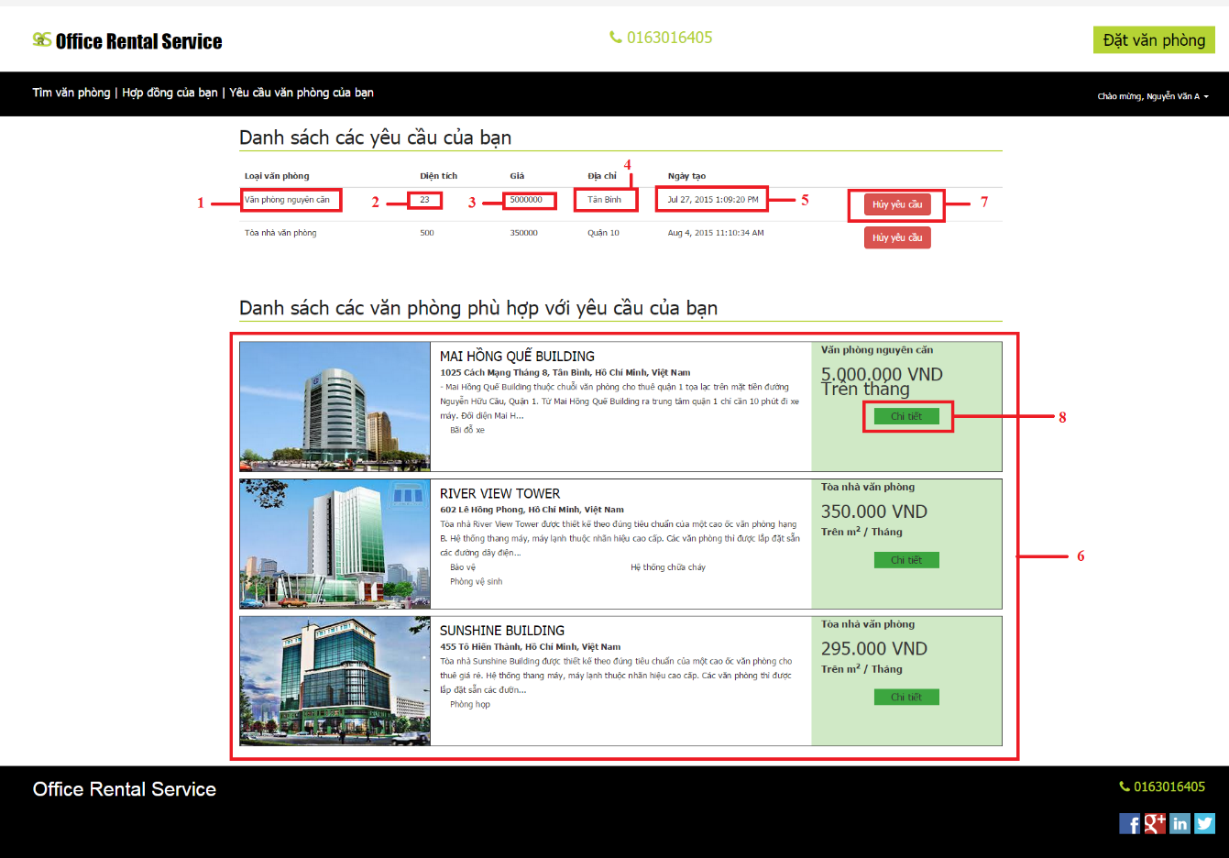

Figure 106: Result request office page

**Fields**

|  |  |  |  |  |  |  |  |
| --- | --- | --- | --- | --- | --- | --- | --- |
| **No** | **Field Name** | **Description** | **Read only** | **Mandatory** | **Control Type** | **Data Type** | **Length** |
| 1 | Name | Name of office | Yes | Yes | Textview | String | N/A |
| 2 | Area | Area of office | Yes | No | Textview | float | N/A |
| 3 | Price | Price of office | Yes | Yes | Textview | int | N/A |
| 4 | Address | Address of office | Yes | Yes | Textbox | bigint | N/A |
| 5 | Create date | Date when customer create request | Yes | Yes | Textview | datetime | N/A |
| 6 | List office | List result office | Yes | No | Listview |  | N/A |

**Buttons/Hyperlinks**

|  |  |  |  |  |
| --- | --- | --- | --- | --- |
| **No** | **Function** | **Description** | **Validation** | **Outcome** |
| 7 | Unsubscribe | Remove request | N/A | Reload page and request has disappear |
| 8 | Office Detail | Show detail of office | N/A | Transfer to office detail page |

#### Contract page

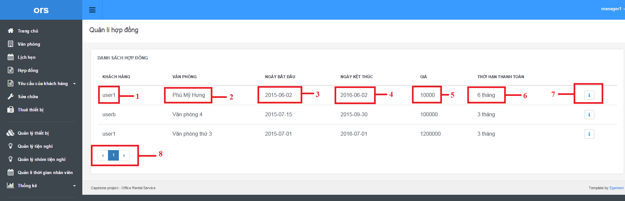

Figure 106: Contract page

**Fields**

|  |  |  |  |  |  |  |  |
| --- | --- | --- | --- | --- | --- | --- | --- |
| **No** | **Field Name** | **Description** | **Read only** | **Mandatory** | **Control Type** | **Data Type** | **Length** |
| 1 | Customer username | Name of customer | Yes | Yes | Textview | String | N/A |
| 2 | Office | Name of office | Yes | Yes | Textview | String | N/A |
| 3 | Start Date | Date when contract start | Yes | Yes | Textview | datetime | N/A |
| 4 | End Date | Date when contract end | Yes | Yes | Textview | datetime | N/A |
| 5 | Price | Price of contract | Yes | Yes | Textview | Int | N/A |
| 6 | Payment Term | Term of Payment | Yes | Yes | Textview | Int | N/A |

**Buttons/Hyperlinks**

|  |  |  |  |  |
| --- | --- | --- | --- | --- |
| **No** | **Function** | **Description** | **Validation** | **Outcome** |
| 7 | Detail | Show detail of the contract | N/A | Transfer to contract detail |
| 8 | Pagination | Page number for contract page | N/A | Transfer to another page in contract page |

#### New contract page

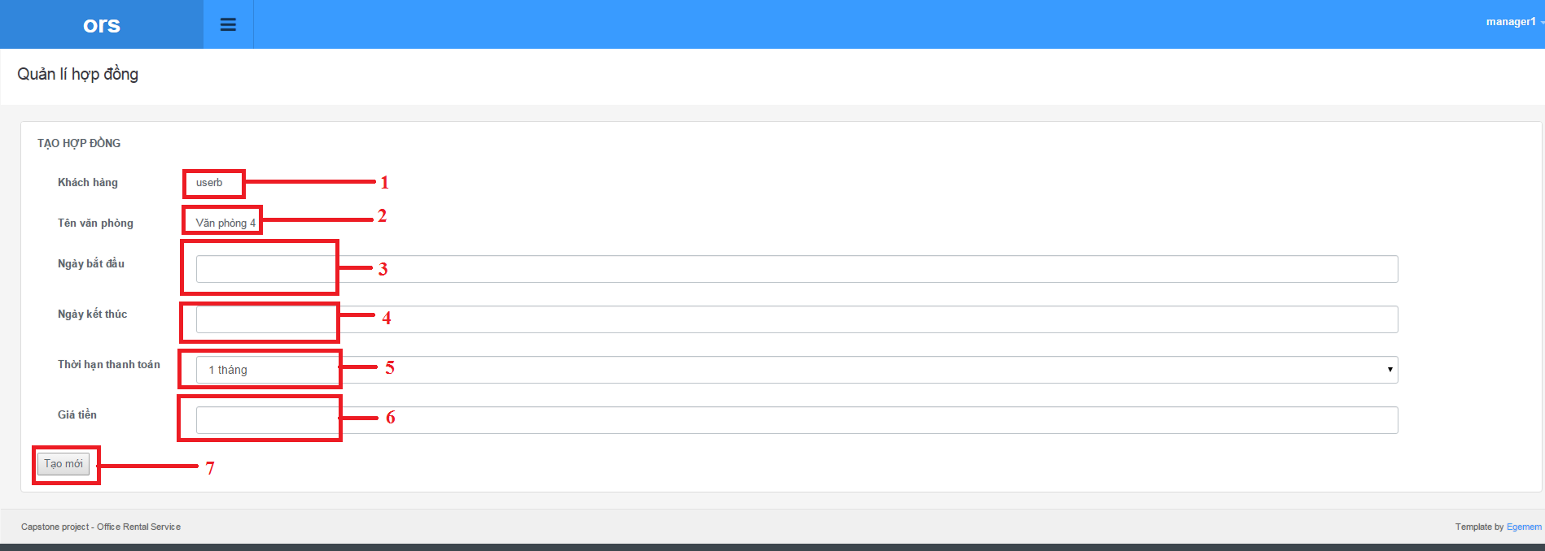

Figure 106: New contract page

**Fields**

|  |  |  |  |  |  |  |  |
| --- | --- | --- | --- | --- | --- | --- | --- |
| **No** | **Field Name** | **Description** | **Read only** | **Mandatory** | **Control Type** | **Data Type** | **Length** |
| 1 | Customer username | Name of customer | Yes | Yes | Textview | String | N/A |
| 2 | Office | Name of office | Yes | Yes | Textview | String | N/A |
| 3 | Start Date | Date when contract start | No | Yes | Textbox | datetime | N/A |
| 4 | End Date | Date when contract end | No | Yes | Textbox | datetime | N/A |
| 5 | Payment Term | Term of Payment | No | Yes | Dropdown list | Int | N/A |
| 6 | Price | Price of contract | No | Yes | Textbox | Int | N/A |

**Buttons/Hyperlinks**

|  |  |  |  |  |
| --- | --- | --- | --- | --- |
| **No** | **Function** | **Description** | **Validation** | **Outcome** |
| 7 | Create contract | Create new contract in database | Yes | Transfer to contract page |

#### Contract detail page

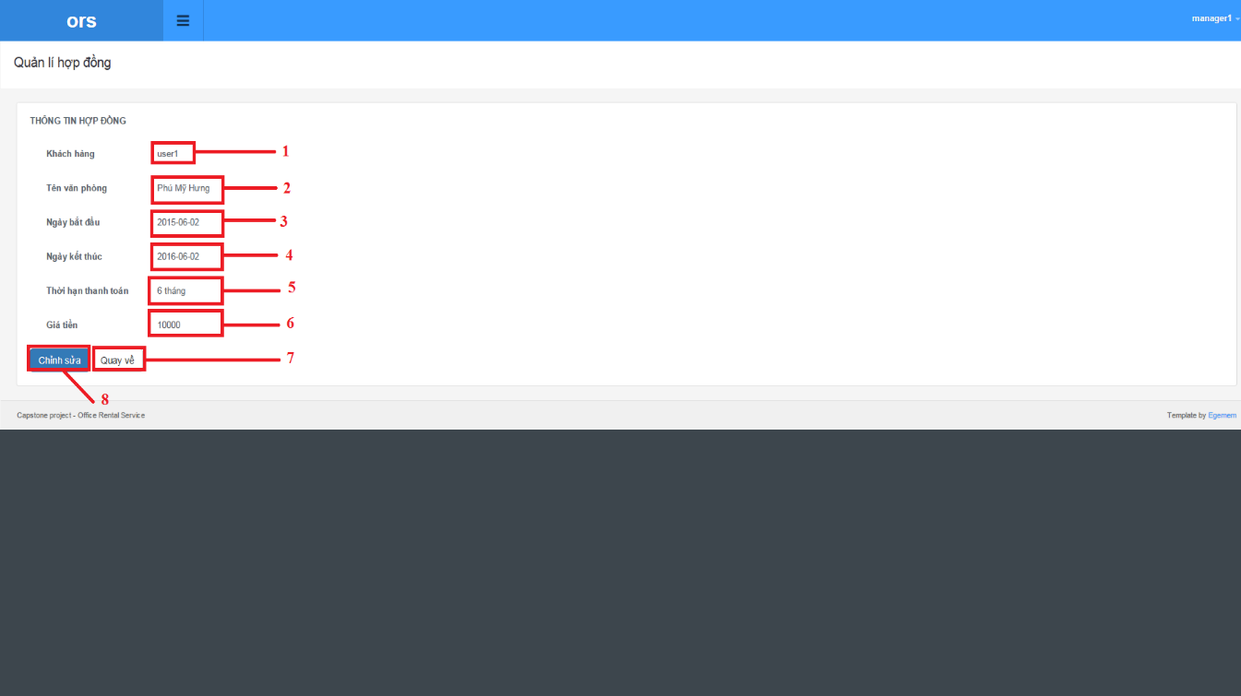

Figure 106: Contract detail page

**Fields**

|  |  |  |  |  |  |  |  |
| --- | --- | --- | --- | --- | --- | --- | --- |
| **No** | **Field Name** | **Description** | **Read only** | **Mandatory** | **Control Type** | **Data Type** | **Length** |
| 1 | Customer username | Name of customer | Yes | Yes | Textview | String | N/A |
| 2 | Office | Name of office | Yes | Yes | Textview | String | N/A |
| 3 | Start Date | Date when contract start | Yes | Yes | Textview | datetime | N/A |
| 4 | End Date | Date when contract end | Yes | Yes | Textview | datetime | N/A |
| 5 | Payment Term | Term of Payment | Yes | Yes | Textview | Int | N/A |
| 6 | Price | Price of contract | Yes | Yes | Textview | Int | N/A |

**Buttons/Hyperlinks**

|  |  |  |  |  |
| --- | --- | --- | --- | --- |
| **No** | **Function** | **Description** | **Validation** | **Outcome** |
| 7 | Return | Return to contract page | N/A | Transfer to contract page |
| 8 | Edit | Go to edit contract page | N/A | Transfer to edit contract page |

#### Edit contract page

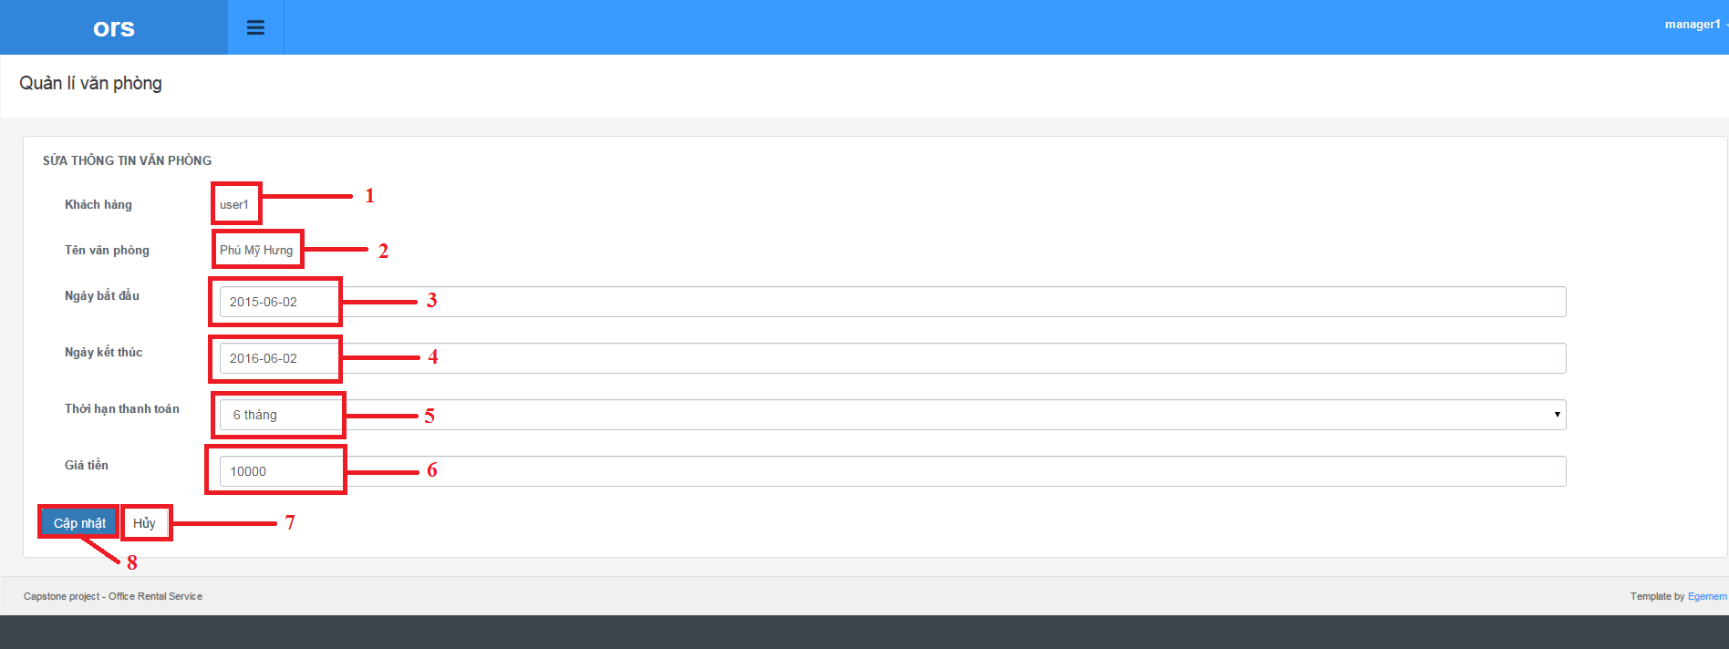

Figure 106: Edit contract page

**Fields**

|  |  |  |  |  |  |  |  |
| --- | --- | --- | --- | --- | --- | --- | --- |
| **No** | **Field Name** | **Description** | **Read only** | **Mandatory** | **Control Type** | **Data Type** | **Length** |
| 1 | Customer username | Name of customer | Yes | Yes | Textview | String | N/A |
| 2 | Office | Name of office | Yes | Yes | Textview | String | N/A |
| 3 | Start Date | Date when contract start | No | Yes | Textbox | datetime | N/A |
| 4 | End Date | Date when contract end | No | Yes | Textbox | datetime | N/A |
| 5 | Payment Term | Term of Payment | No | Yes | Dropdown list | Int | N/A |
| 6 | Price | Price of contract | No | Yes | Textbox | Int | N/A |

**Buttons/Hyperlinks**

|  |  |  |  |  |
| --- | --- | --- | --- | --- |
| **No** | **Function** | **Description** | **Validation** | **Outcome** |
| 7 | Cancel | Return to contract page | N/A | Transfer to contract page |
| 8 | Update | Update contract | Yes | Transfer to contract page |

#### View request contract page

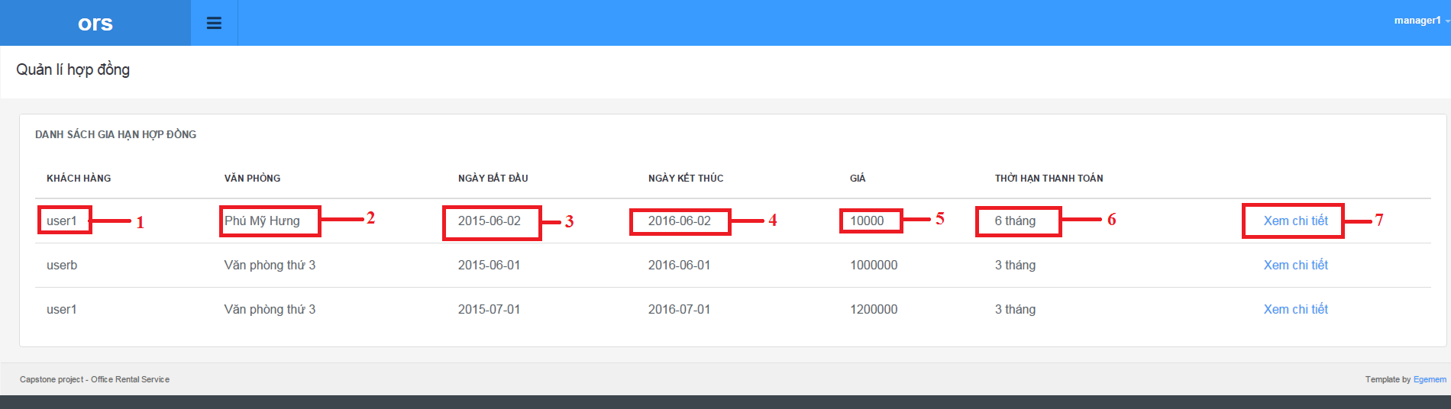

Figure 106: View request contract page

**Fields**

|  |  |  |  |  |  |  |  |
| --- | --- | --- | --- | --- | --- | --- | --- |
| **No** | **Field Name** | **Description** | **Read only** | **Mandatory** | **Control Type** | **Data Type** | **Length** |
| 1 | Customer username | Name of customer | Yes | Yes | Textview | String | N/A |
| 2 | Office | Name of office | Yes | Yes | Textview | String | N/A |
| 3 | Start Date | Date when contract start | Yes | Yes | Textview | datetime | N/A |
| 4 | End Date | Date when contract end | Yes | Yes | Textview | datetime | N/A |
| 5 | Price | Price of contract | Yes | Yes | Textview | Int | N/A |
| 6 | Payment Term | Term of Payment | Yes | Yes | Textview | Int | N/A |

**Buttons/Hyperlinks**

|  |  |  |  |  |
| --- | --- | --- | --- | --- |
| **No** | **Function** | **Description** | **Validation** | **Outcome** |
| 7 | Detail | Show detail of the contract | N/A | Transfer to contract detail |
|  |  |  |  |  |

#### Extend contract page

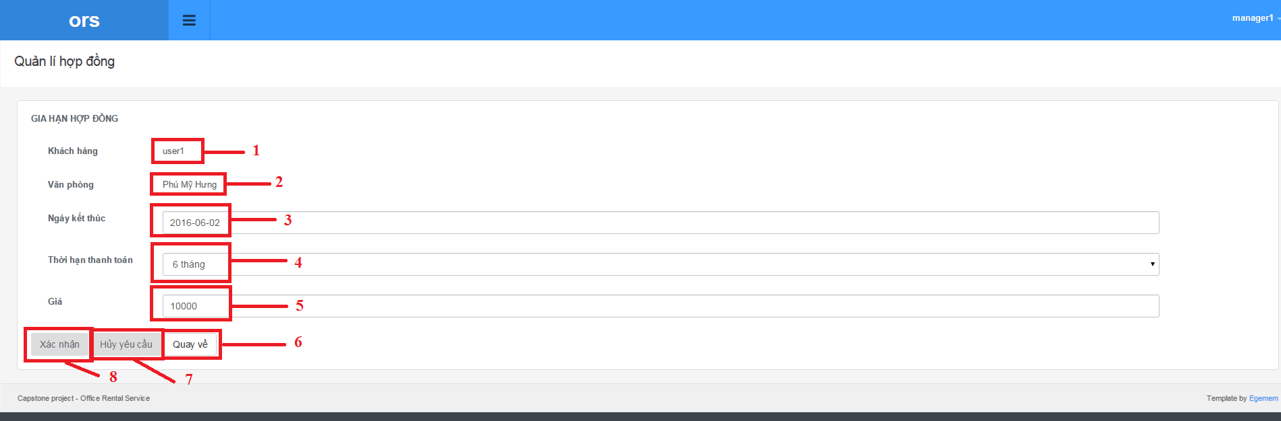

Figure 106: Extend contract page

**Fields**

|  |  |  |  |  |  |  |  |
| --- | --- | --- | --- | --- | --- | --- | --- |
| **No** | **Field Name** | **Description** | **Read only** | **Mandatory** | **Control Type** | **Data Type** | **Length** |
| 1 | Customer username | Name of customer | Yes | Yes | Textview | String | N/A |
| 2 | Office | Name of office | Yes | Yes | Textview | String | N/A |
| 3 | End Date | Date when contract end | No | Yes | Textview | datetime | N/A |
| 4 | Payment Term | Term of Payment | No | Yes | Textview | Int | N/A |
| 5 | Price | Price of contract | No | Yes | Textview | Int | N/A |

**Buttons/Hyperlinks**

|  |  |  |  |  |
| --- | --- | --- | --- | --- |
| **No** | **Function** | **Description** | **Validation** | **Outcome** |
| 6 | Return | Return to request contract page | N/A | Transfer to request contract page |
| 7 | Cancel request | Cancel the request | N/A | Transfer to request contract page |
| 8 | Update | Extend the contract | N/A | Transfer to request contract page |

#### Return contract page

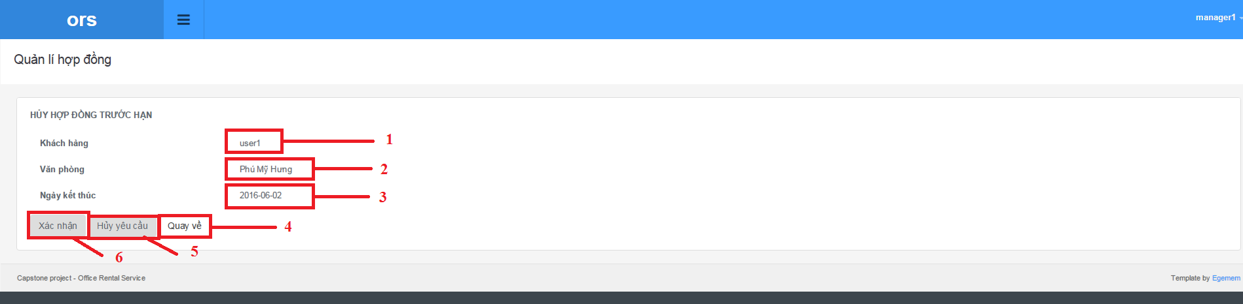

Figure 106: Return contract page

**Fields**

|  |  |  |  |  |  |  |  |
| --- | --- | --- | --- | --- | --- | --- | --- |
| **No** | **Field Name** | **Description** | **Read only** | **Mandatory** | **Control Type** | **Data Type** | **Length** |
| 1 | Customer username | Name of customer | Yes | Yes | Textview | String | N/A |
| 2 | Office | Name of office | Yes | Yes | Textview | String | N/A |
| 3 | End Date | Date when contract end | No | Yes | Textview | datetime | N/A |

**Buttons/Hyperlinks**

|  |  |  |  |  |
| --- | --- | --- | --- | --- |
| **No** | **Function** | **Description** | **Validation** | **Outcome** |
| 4 | Return | Return to request contract page | N/A | Transfer to request contract page |
| 5 | Cancel request | Cancel the request | N/A | Transfer to request contract page |
| 6 | Update | Expired the contract | N/A | Transfer to request contract page |